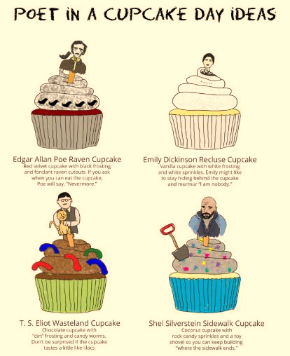

TAREA PENDIENTE!!!!! TORTAS VICKY, PONTE LAS PILAS……!!!!!!
LA WEB ESTÁ ABANDONADA

KIT RANGE PROSPER DIRECT ARGUE EXCUSE INHERIT CLARIFY MOMENT SOLID VENDOR RIDE
SUPPLY GROCERY GHOST DIAL PITCH EPISODE ENABLE RECOVER ISOLATE GAME WHIP STADIUM

